AI Use Declaration Form
Course: Introduction to Artificial Intelligence
Lab Title: Lab 1 Part A — Uninformed Search Algorithms
Student Name: _____Fida Ukwishaka______________________________________________
Student ID: ________47582028______________________________________________
GitHub Repository Link: ___https://github.com/Fida-Ukwishaka/Fida_Ukwishaka_Lab1 ________________________________________
Date Submitted: _____June, 20th 2026_____________________________________________

1. AI Use Summary
Question | Student Response
Did you use any AI tool for this lab? | Yes
Estimated percentage of the work influenced by AI | 9%
Did you attach evidence of AI use where applicable? | Yes

2. Details of AI Use
Complete the table below for each AI tool used. Add more rows where necessary.
Name of AI Tool Used | Purpose for Using the Tool | Prompt or Instruction Given to the Tool | Part(s) of the Work Influenced by the Tool | How I Verified, Edited, or Improved the AI Output
ChatGPT | Error Handling | Screenshot of the error | Lab1A, part 13  Lab1B, part 3.1 | I compared the response with the context and if the answer makes sense and in line with what the problem was.  I also asked for examples to better understand the response.

3. Attachment of AI Output Evidence
Where required, attach evidence of AI use. Tick all that apply. Add more rows where necessary.
Evidence Type | Attached? (Yes, No, N/A) | File Name
AI-generated draft
Prompt history
Screenshot of AI interaction | yes | 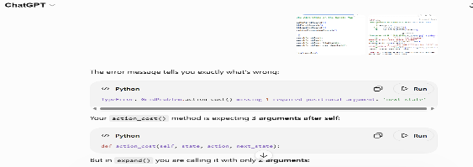
Exported AI conversation
AI-generated code snippet
Revised version showing student input

4. Student Declaration
I declare that:
Declaration Statement | Response (Yes/No)
The submitted work is my own work. | Yes
Any use of AI tools has been clearly declared in this form. | Yes
The prompts, instructions, and AI-generated outputs have been disclosed where applicable. | Yes
I reviewed, tested, edited, and improved any AI-generated content before submission. | Yes
My AI usage does not exceed 25% of the entire work. | Yes
I understand that undeclared or excessive AI use may be treated as academic misconduct. | Yes

Student Signature: ____Fida Ukwishaka_______________________________________
Date: __________June, 20th , 2026_________________________________

